Lab 11.1

Task 1 :

Prompt : - 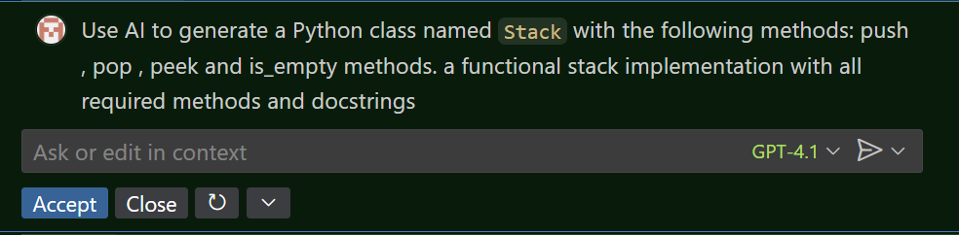

Code : - 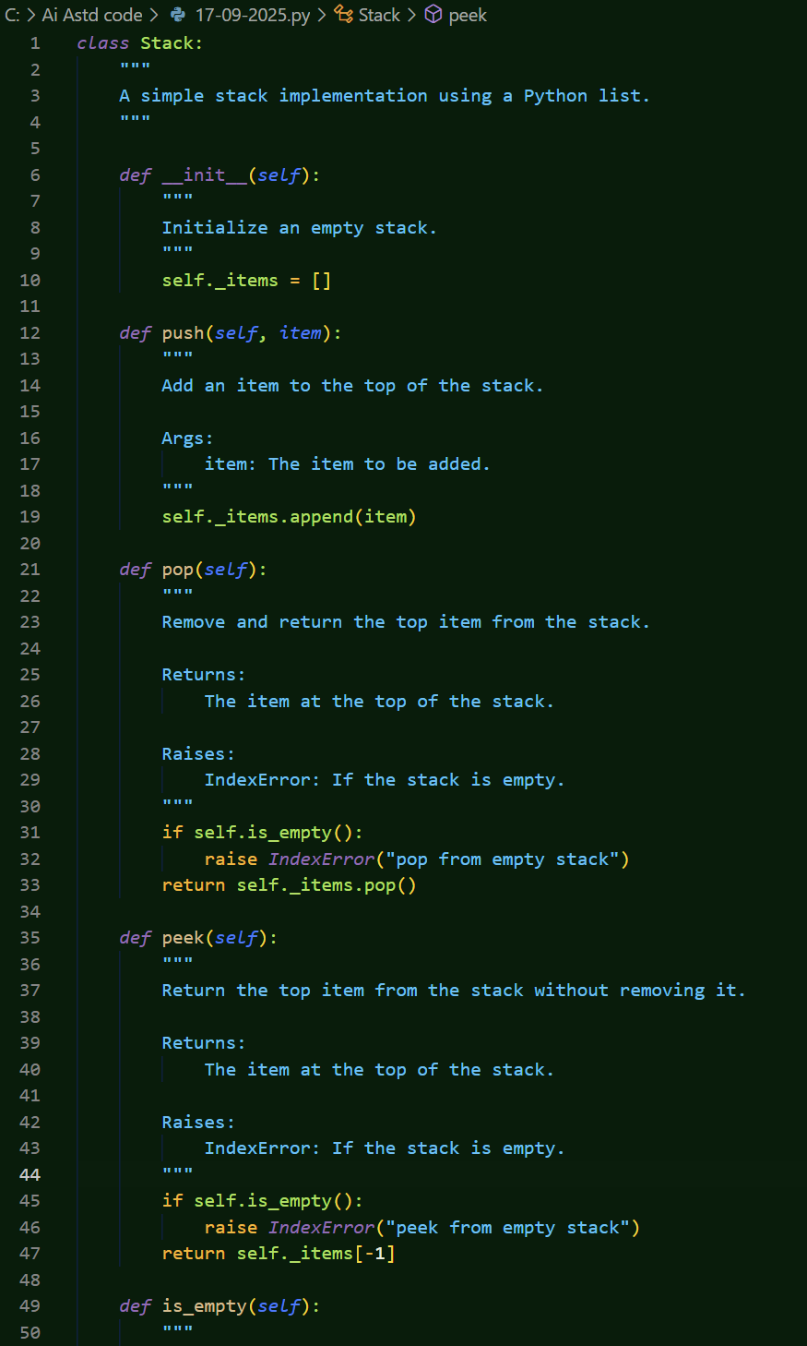

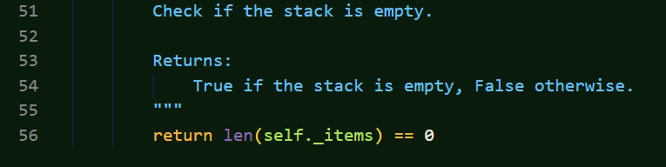

Task 2 _

Prompt :-

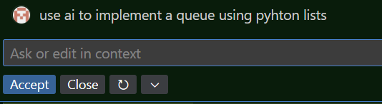

Code “_

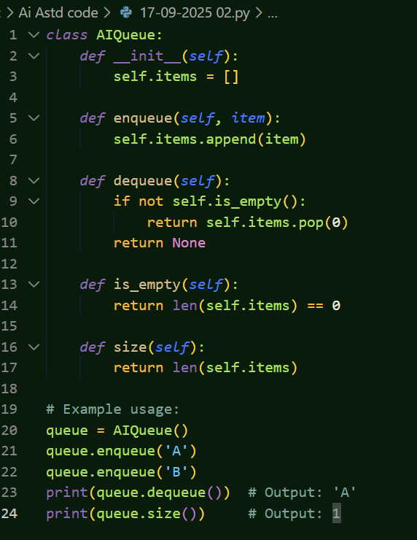

Task 3 –

Prompt :-

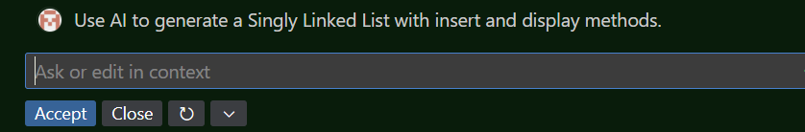

Code:-

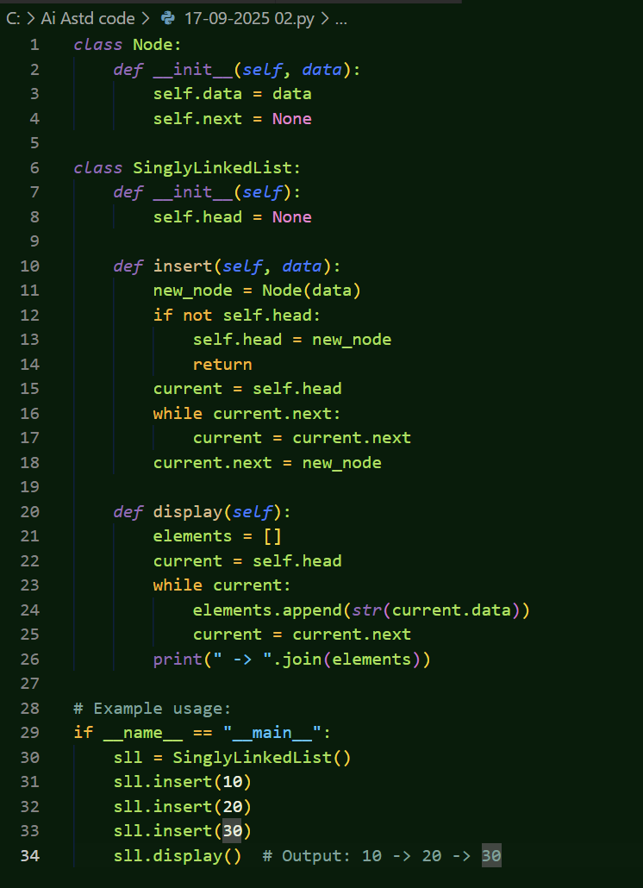

Task 4:-

Prompt :-

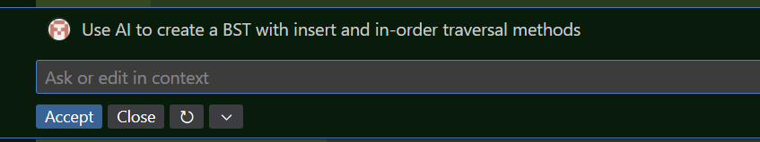

Code:-

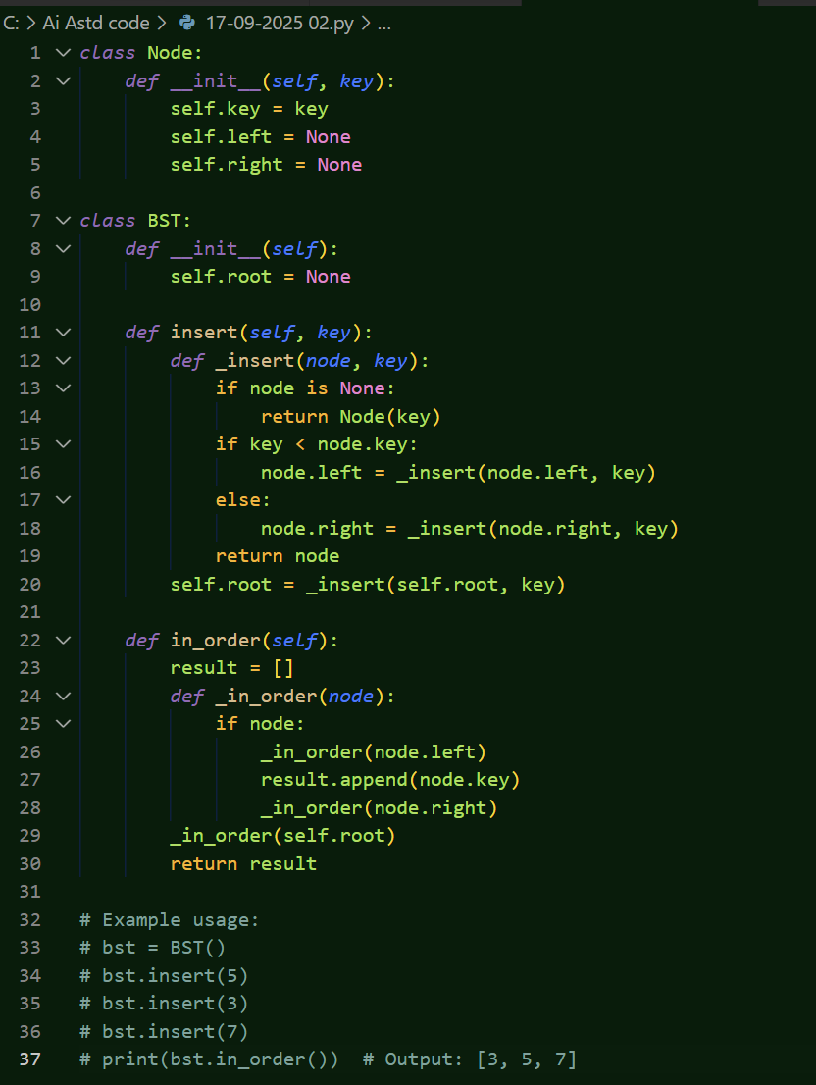

Task 5:-

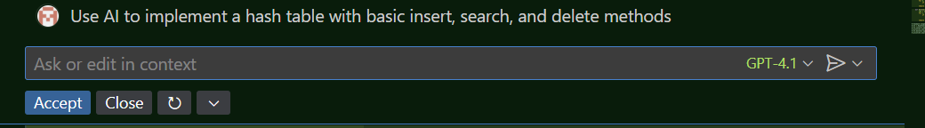

Code:-

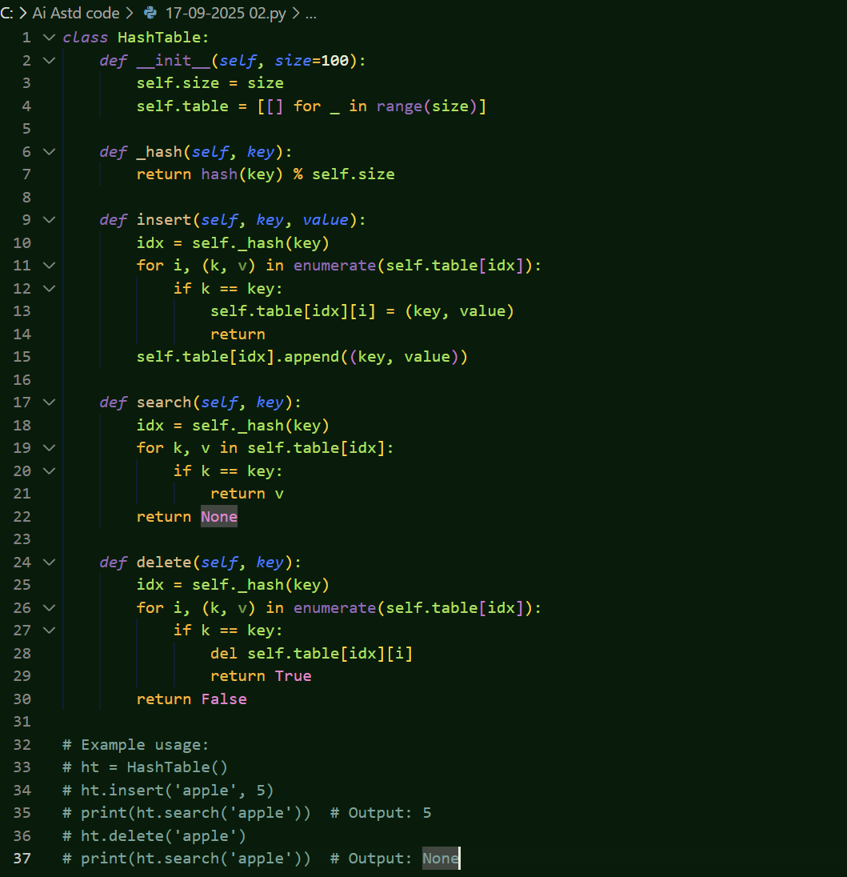

Task 6:- \

Prompt_

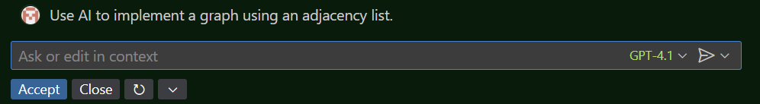

Code :-

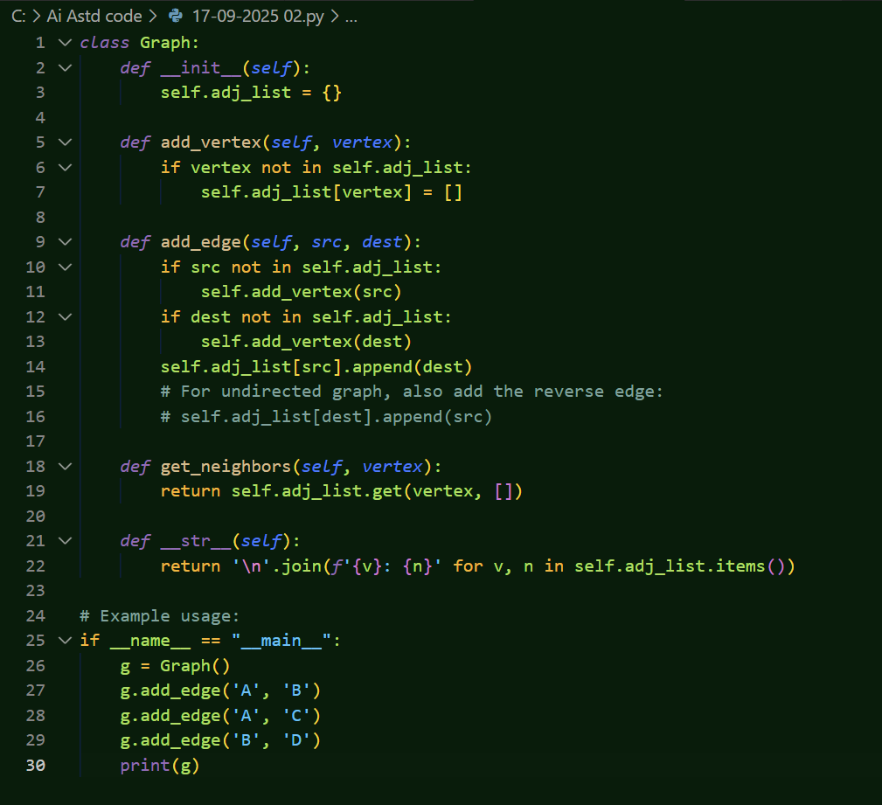

Task 7 :-

Prompt_

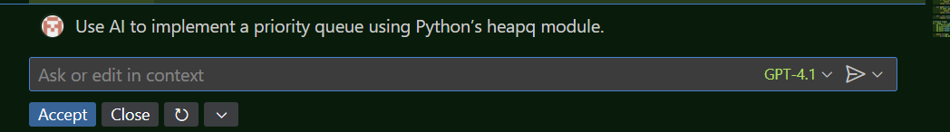

Code :-

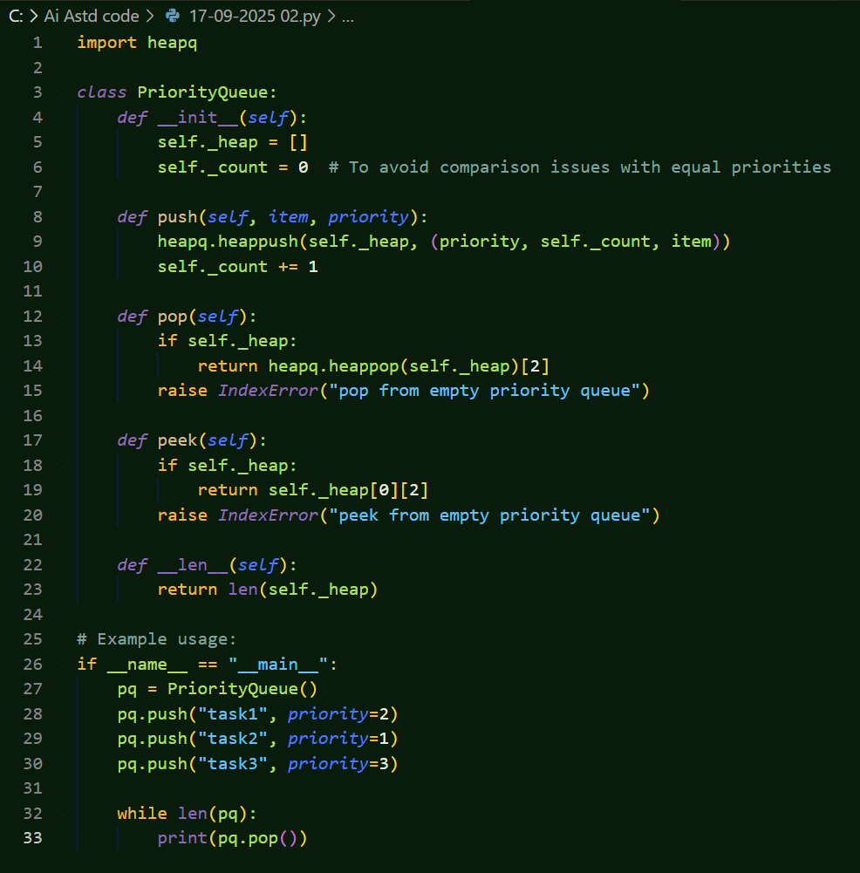

Task 8:--

Prompt :-

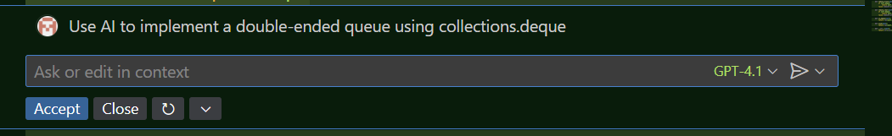

Code:-\

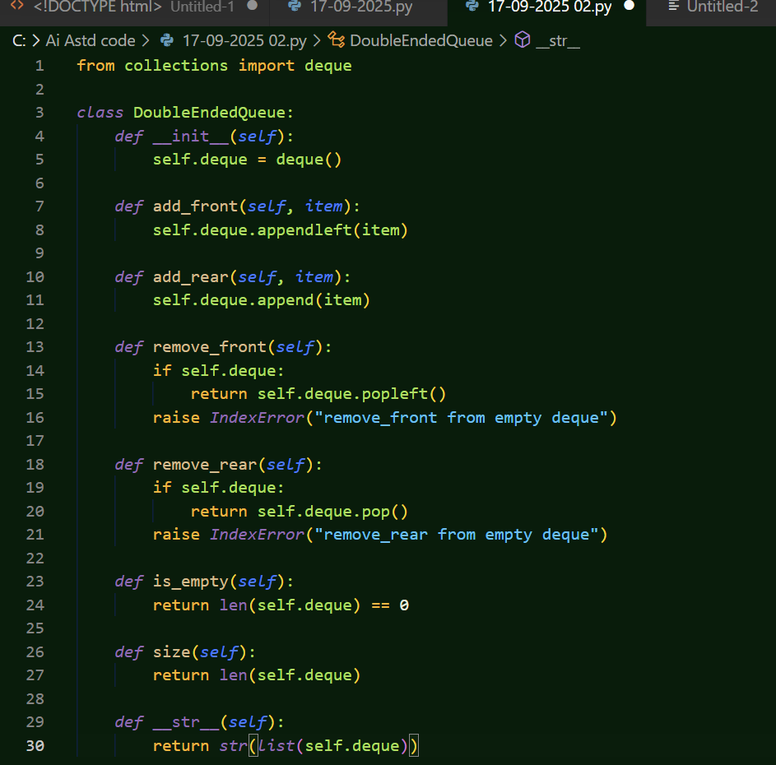

Task 9 :-

Prompt :-

Code:-

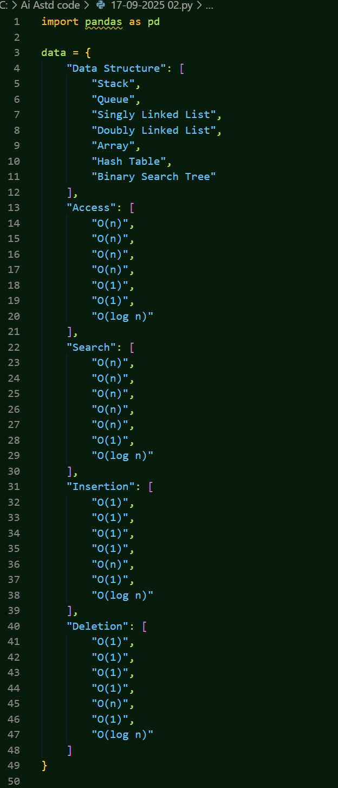

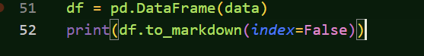

Task 10 :-

Prompt : -

